

Unit 804, 8th Floor, 20th Drive Corporate Center McKinley Business Park, Bonifacio Global City,

Taguig 1634 Philippines www.decraroofasia.com

# Quotation No. : 1000

**4 November 2021**

# Kompas Resorts & Hotels Inc. Brgy Doljo Panglao

**6340 Bohol**

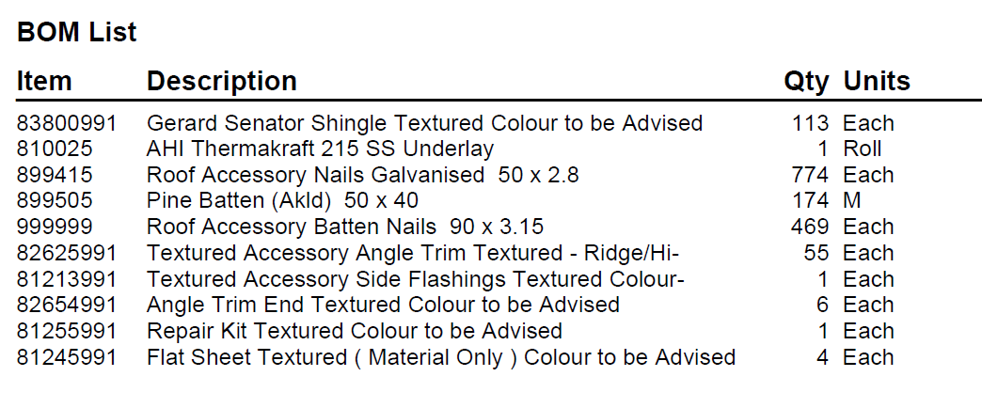

# Supply :

Roof Total Php 75,437.50

12% VAT 9,052.50

Total Php 84,490.00

1. Method of roofing works is direct to battens installation/conventional method.

2. Estimated quantities are based on roofing plans provided by Customer.

1. Quote allows for the supply and fitting of building paper underlay and battens/purlins.
2. Quote valid for 30 days only.
3. The quotation is based on dimensions as detailed on the attached plan and is subject to amendment if varied.
4. This price quotation does not include delivery cost.

## Representative: Mobile Phone: Email:

**Roof Pitch(s):**

## Main Rafter Spacing: